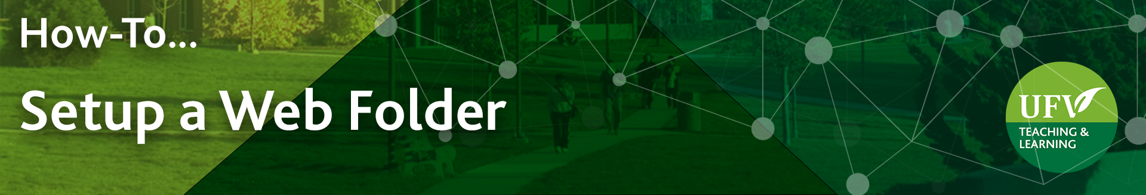

Setup a Web Folder
Setting up a web folder allows you to download and save files and folders from your Blackboard Course Content Collection. This is the easiest method if you have a large amount of files and folders in your course content collection.
A Web Folder also allow you to easily reorganize your course content collection without breaking links in Blackboard.
- Log into myClass: https://ufv.ca/myclass/ and click on your Blackboard course
- In the left side menu, under Course Management, click on Content Collection
and click on your course ID.
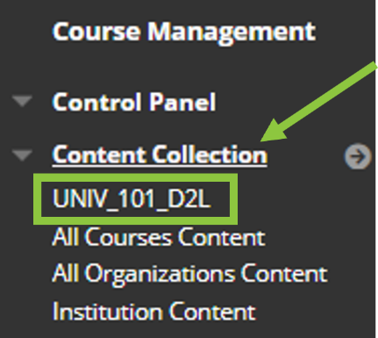

- Click on Set Up Web Folder
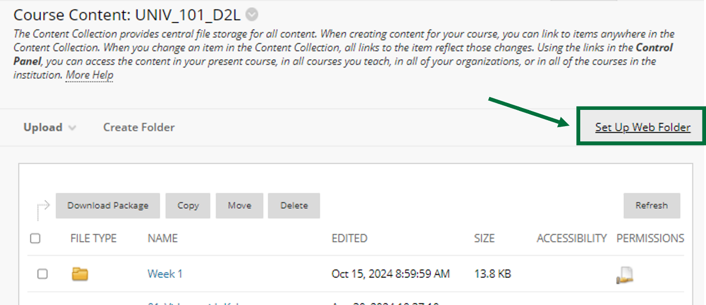

- Copy the URL highlighted in the Current Web address
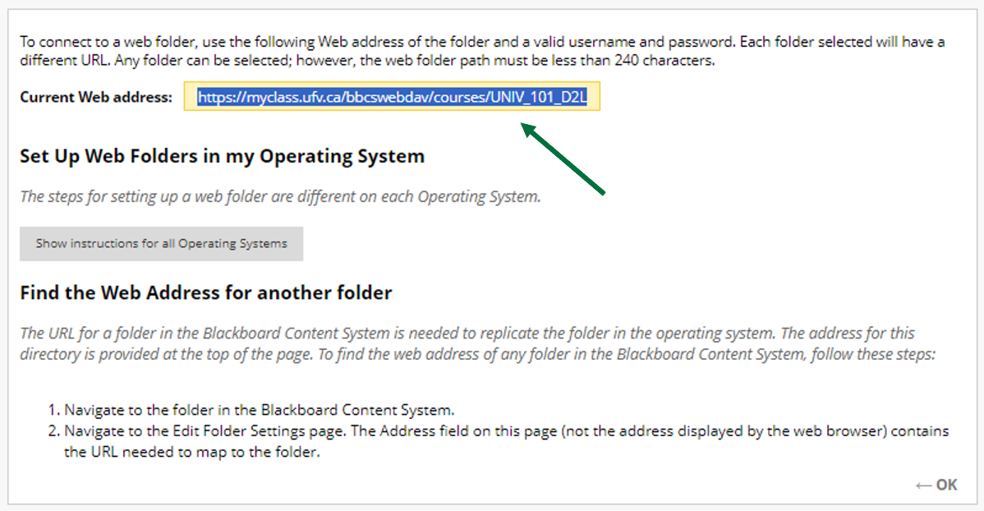
The next steps are different whether you are using a Windows or a MAC device. If you are using a MAC, see the link at the bottom of this document.

If you are using a Windows device:
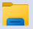
- Open File Explorer

- Click on This PC

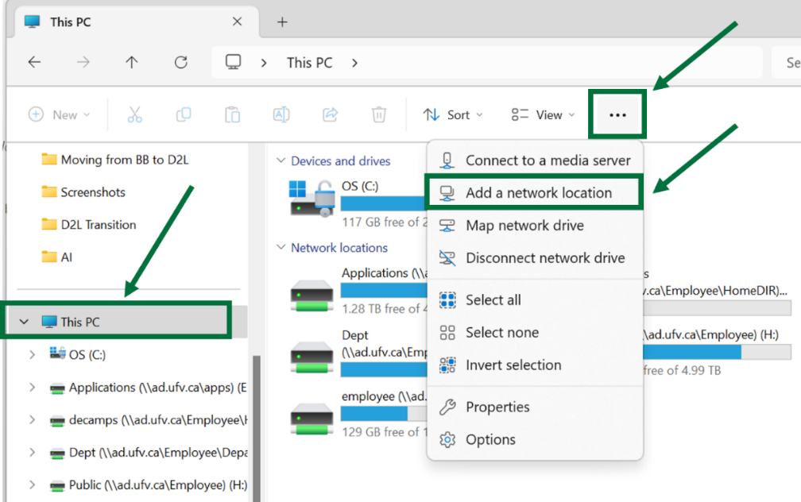
- Select Add a network location in the ribbon at the top of the page. This option may be hidden in the More options or ellipsis (3 horizontal dots).
- Click on Next
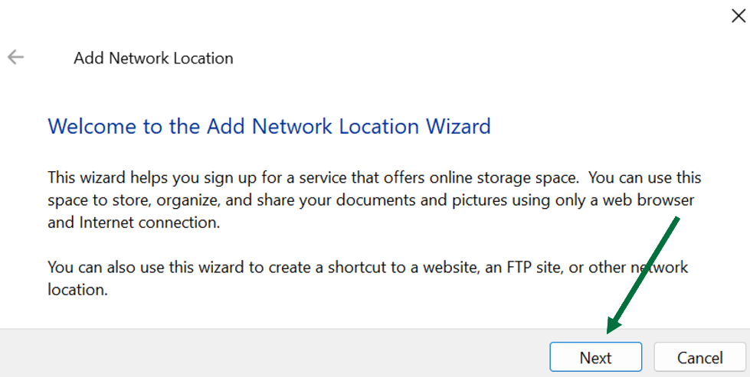

- When asked where you want to create the network location, click on Choose a custom network location. Click on Next.
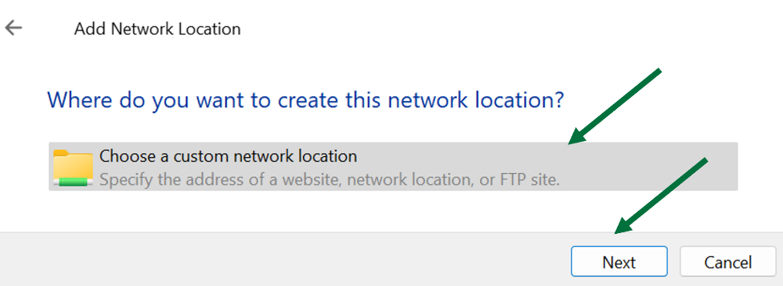

- When asked for the location of your website, paste the web address you copied from the steps above. Click on Next.
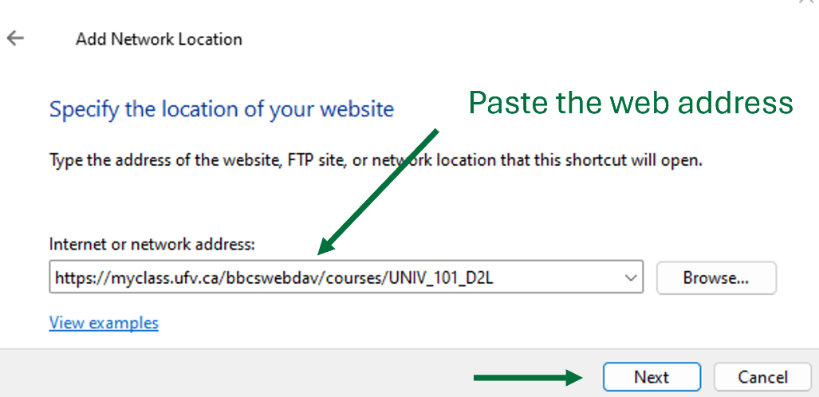

- If you are prompted to connect to myclass.ufv.ca, enter your username and password. Click on OK.

- You will be prompted to enter a name for the location. Enter a name and select Next.
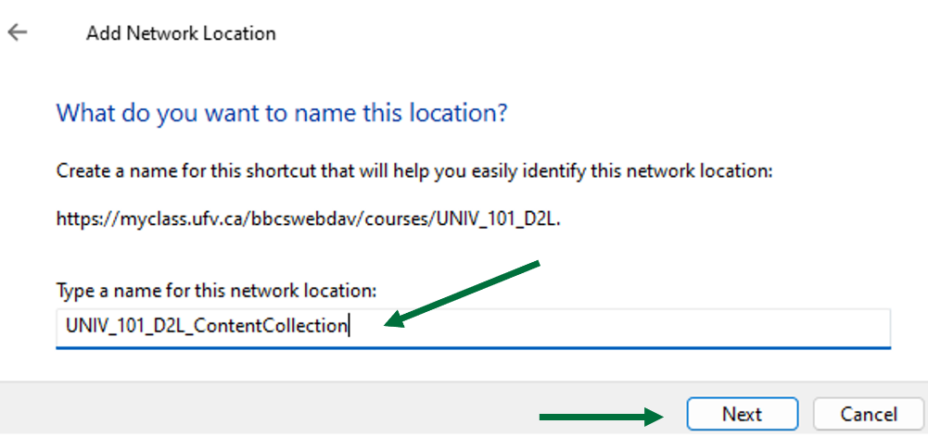
- On the Completing the Add Network Location Wizard page, select Finish.
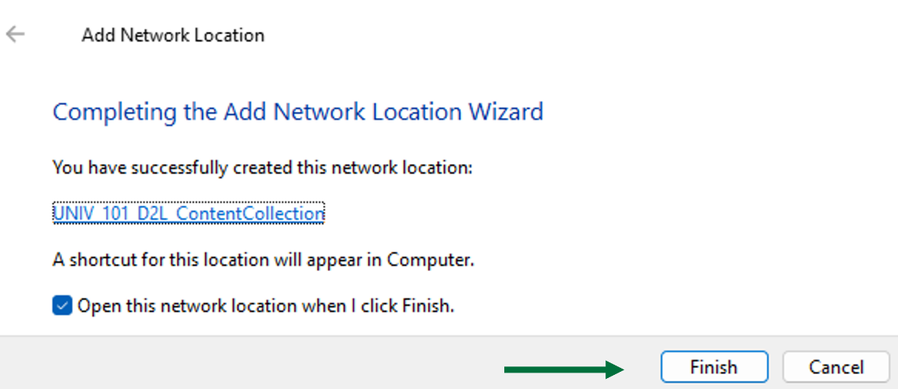

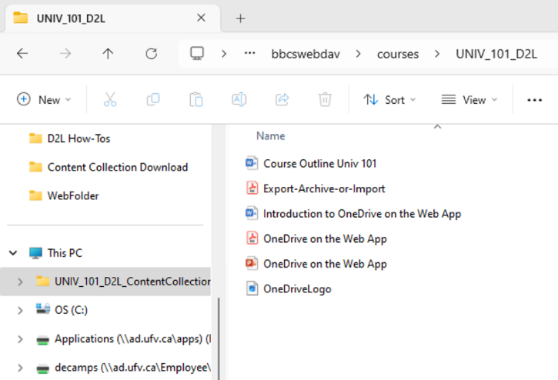
- The web folder will open. It will now be listed in This PC under the folder name given.

- This Web Folder is like a mirror to your course Content Collection in Blackboard. Any changes you make in that folder will be automatically reflected in the content collection in blackboard.
Note: You can organize your Web Folder and move files into new folders or delete duplicated files. If you create a new folder in your Web Folder, it will also appear in your Content Collection. If you move files within your Web Folder, they will also move in your Content Collection, and if there was a link to that file in Blackboard, the link will still be valid. If you delete a file from the Web Folder, it will be deleted in your content collection too, and if you had a link to that deleted file in blackboard, the link will be broken.

- Once you are ready to copy everything to your own computer, open a separate File Explorer by pressing on the Windows key and letter E on the keyboard simultaneously.
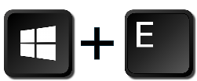

Navigate to where you would like to copy the content collection on your computer or on your UFV OneDrive. You may want to create a new folder with the course name or ID for clarity.

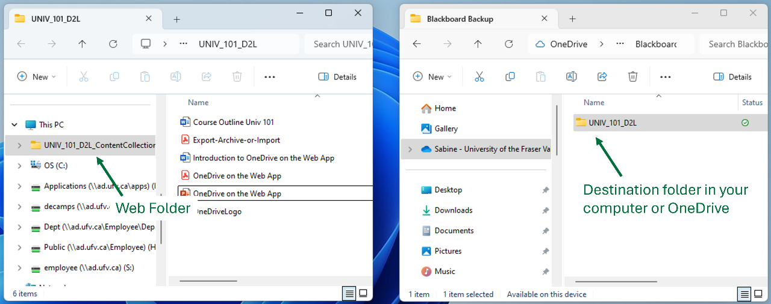

- With your destination folder and the web folder open, you can drag and drop specific files or folders to copy them between the two folders. DO NOT drag the entire Web Folder as this will not copy its content.
If you prefer, you can also use copy and paste to copy files and folders between the web folder and the destination folder on your computer.
- Check that everything is accessible, and that all the copied documents can be opened properly.

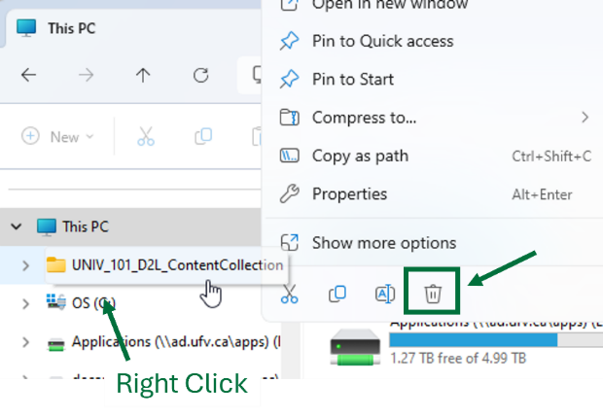
- After you copy all files and folders you wish to keep, make sure you disconnect from the web folder by deleting the Web Folder itself, so that you don’t inadvertently delete other files that you needed in Blackboard. Make absolutely sure that you do not delete a folder within that Web Folder as it will also delete it from your course content collection.

If you are using a MAC device:
Web Folders are called Shared Location on Mac devices. The instructions to set up a shared location for MAC can be found in the Blackboard Learn help at this link.

Looking for more tutorials? Check out our written How-To Guides at: https://www.ufv.ca/teaching-and-learning/Brightspace We also have video How-Tos at video.ufv.ca and you can always email us at asktlc@ufv.ca
