

Save and View a Blackboard Portfolio
This allows you to download and save a portfolio you created in Blackboard and view it in a web browser. It is not possible to transfer your blackboard portfolio directly into Brightspace.
- Log into myClass: https://ufv.ca/myclass/

- In the left side menu, click on Tools, and click on Portfolios
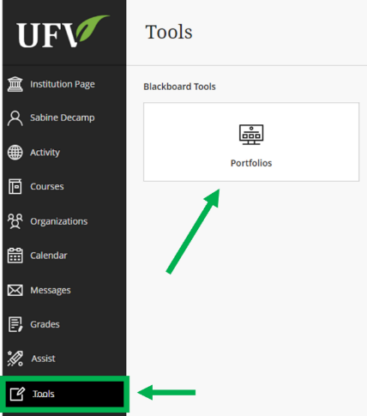

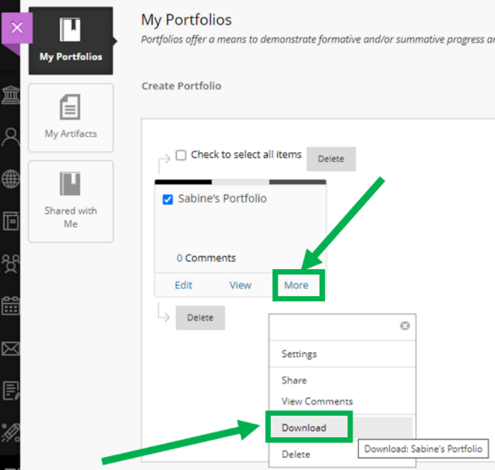
- In My Portfolios, select the portfolio you would like to save, and click on More.
Then select Download.

- In the new window that appears, click on Click to download Portfolio.
You may be able to choose the destination of your file and click Save; otherwise it will be saved in your downloads folder. It takes a few minutes, so be patient!
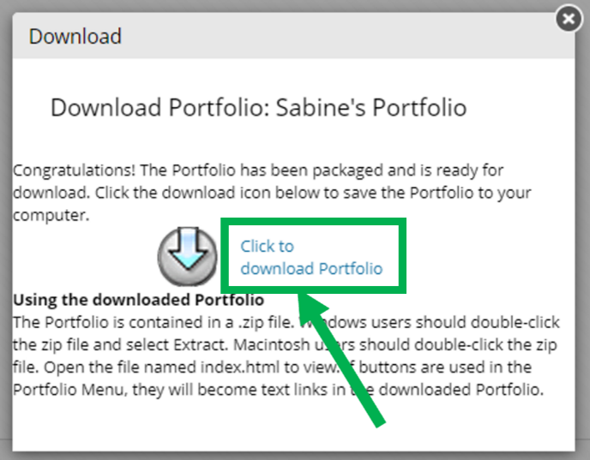
Once it is downloaded, you can close the Download pop-up window by clicking on the x or anywhere outside the window.
- Your portfolio has been downloaded as a .zip file. To view your Portfolio, you have to first extract all the content of that zip file:

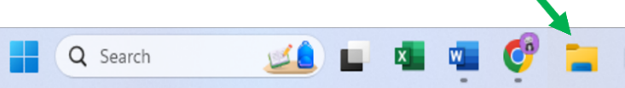
- On a Windows device, open file explorer
- Right-click on the PortfolioDownload.zip file
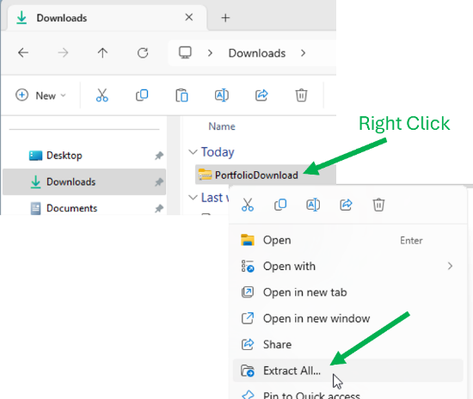
and choose Extract All
- On a mac computer, double click the PortfolioDownload.zip file in your Finder App.The unzipped files will appear in a new folder with the same name, located in the same location as the .zip file

- To open and view your portfolio:
- Click on the folder to open it up and see what files are inside.
- Double click on the index.html file. Your portfolio will open in a web browser.
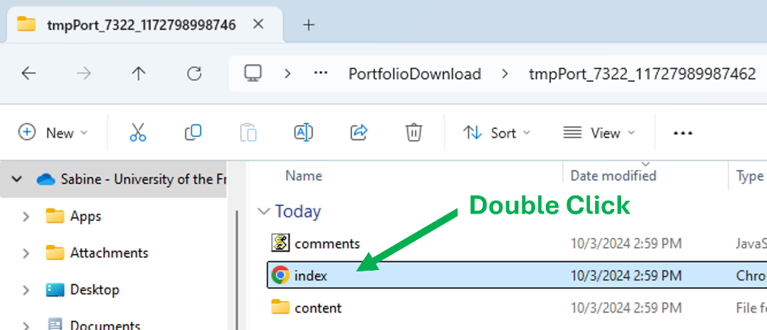

Check that everything is accessible, and that all the documents attached can be opened properly.

Looking for more tutorials? Check out our written How-To Guides at: https://www.ufv.ca/teaching-and-learning/Brightspace We also have video How-Tos at video.ufv.ca and you can always email us at asktlc@ufv.ca


